Supplementary Material
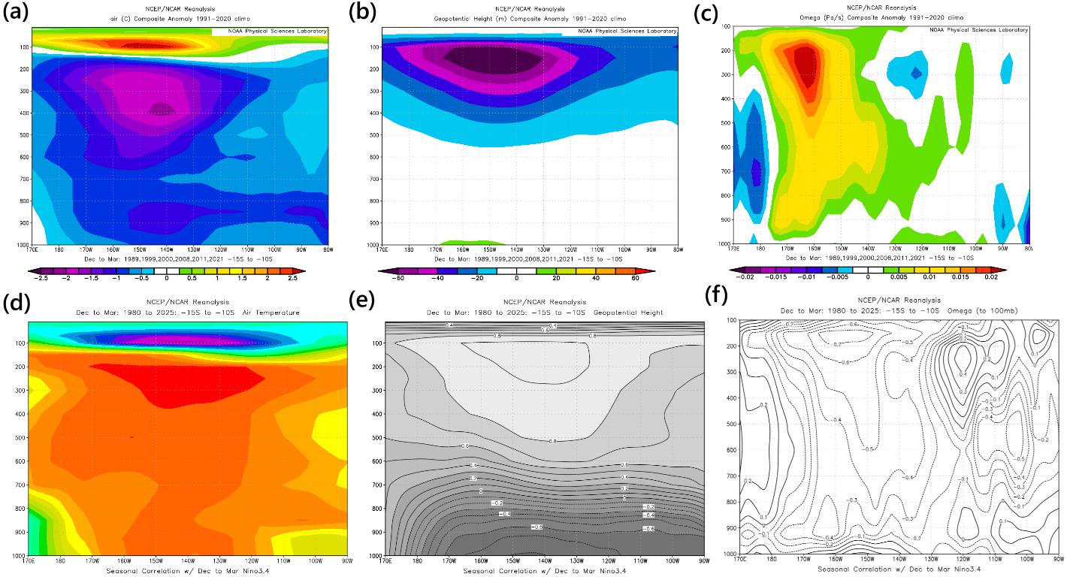
Supplementary Figure 1: Bipolar Atmospheric Response to ENSO over the Tropical Southeast Pacific (15°S–10°S). This figure statistically validates the coupled dynamical-radiative mechanisms linking ENSO to the upper-tropospheric/lower-stratospheric circulation over the tropical southeast Pacific (15°S–10°S) during December–March, presenting both correlation-based El Niño signals and composite-based La Niña anomalies from NCEP/NCAR Reanalysis: panels (a–c) show seasonal correlations with the Niño 3.4 index (1980–2025), revealing during El Niño a robust vertical temperature dipole (warming aloft at ~300 hPa overlying cooling in the lower stratosphere at ~100–150 hPa; panel a), coincident with positive geopotential height anomalies (indicating column expansion and an anticyclone; panel b) and strong upward motion (negative omega; panel c) over the central/eastern domain, collectively illustrating how convection drives tropospheric warming and atmospheric thickening; panels (d–f) present La Niña composites (1989, 1999, 2000, 2008, 2011, 2021 minus 1991–2020 climatology), which reveal the symmetric, mirror-image response — tropospheric cooling and stratospheric warming (panel d), anomalous low pressure/trough (panel e), and large-scale subsidence (positive omega; panel f), confirming the bipolar, robust nature of the system and validating the physical mechanisms proposed in the main text.

Supplementary Table 1: Ranked Causal Pathways in the ENSO–Stratosphere–Ocean System (1980–2023). Pathways are ordered by total Causality Evidence Score, which integrates four independent lines of evidence: Granger causality (2 pts), statistically significant Transfer Entropy (TE; 2 pts; p < 0.05, ≥1 successful lag), Convergent Cross Mapping (CCM; 1.5 pts; ρ > 0.38), and partial correlation (1 pt). Strength is classified as STRONG (score ≥ 3.5) or MODERATE (score ≥ 2.0). TE significance was assessed using phase-randomised surrogate testing (n = 500); “Successful_Lags = 12” for all relationships confirms robust multi-lag information transfer. Critically, while CCM and Granger suggest bidirectional coupling between ozone and tropospheric temperatures, only forward directions (ozone → X) exhibit significant TE, revealing unidirectional causal influence from stratospheric ozone to the troposphere and ocean heat content.
Rank Causal Pathway Granger TE CCM Partial Score Strength Key evidence
1 O₃ → T_100mb 2 2 1.5 1 6.5 STRONG Full + unidirectional TE
2 O₃ → T_300mb 2 2 1.5 1 6.5 STRONG Full + unidirectional TE
3 T_100mb→T_300mb 2 2 1.5 1 6.5 STRONG Strong vertical coupling
4 T_300mb→T_100mb 2 2 1.5 1 6.5 STRONG Weaker TE but still sign
5 T_100 mb → OHC 2 2 0 0 4.0 STRONG Granger + TE
6 T_300 mb → OHC 2 2 0 0 4.0 STRONG Granger+ TE (p=0.0098)
7 O₃ → OHC 2 2 0 0 4.0 STRONG Novel LSO→OHC link
8 T_100 mb → O₃ 2 0 1.5 0 3.5 STRONG Granger + CCM (no TE)
9 T_300 mb → O₃ 2 0 1.5 0 3.5 STRONG Granger + CCM (no TE)
10 OHC → O₃ 2 0 0 0 2.0 MODERATE Granger-only
11 OHC → T_100 mb 2 0 0 0 2.0 MODERATE Granger-only
12 OHC → T_300 mb 2 0 0 0 2.0 MODERATE Granger-only

Supplementary Table 2: Depth-resolved UV-B radiative heating and annual cumulative energy deposition in the upper ocean driven by lower-stratospheric ozone anomalies during El Niño events. Volumetric heating rates (W m⁻³) and cumulative energy deposition (MJ m⁻² yr⁻¹) as a function of depth for pre-1998 (ozone deficit –5.6 DU, surface heating rate q₀ = 0.26 W m⁻³) and post-1998 (ozone deficit –7.5 DU, q₀ = 0.35 W m⁻³) climate regimes. Calculations use a Beer–Lambert attenuation coefficient k = 0.14 m⁻¹ (e-folding depth 7.14 m) representative of clear tropical Pacific waters. Cumulative energy is integrated analytically over a whole year to reflect the multi-month persistence of the stratospheric ozone anomaly and near-continuous high insolation in the 15°S–10°S southeast Pacific region. Total annual energy deposition increases from 58.7 MJ m⁻² yr⁻¹ (pre-1998) to 79.1 MJ m⁻² yr⁻¹ (post-1998), a 34.8% increase. More than 93.9 % of this energy is deposited in the uppermost 20 m in both periods. Still, the post-1998 shoaling of the mixed layer (from ~39 m to ~31 m) traps this additional radiative input in a shallower layer, intensifying surface warming.
Depth (m) | Heating Pre (W m⁻³) | Heating Post (W m⁻³) | Cumulative Pre-1998 (MJ m⁻² yr⁻¹) | Cumulative Post-1998 (MJ m⁻² yr⁻¹)
0 | 0.260 | 0.350 | 0.00 | 0.00
5 | 0.129 | 0.174 | 29.5 | 39.7
10 | 0.064 | 0.086 | 44.1 | 59.5
15 | 0.032 | 0.043 | 51.4 | 69.3
20 | 0.016 | 0.021 | 55.1 | 74.3
25 | 0.008 | 0.011 | 56.8 | 76.6
30 | 0.004 | 0.005 | 57.7 | 77.8
Total | — | — | 58.7 | 79.1

